PYTHON PROJECT

Task 1: Import Libraries and Load Data:
- Import required libraries:
  - pandas
  - numpy
  - matplotlib
  - seaborn
- Load the dataset into a pandas DataFrame.
- Display the first few rows.
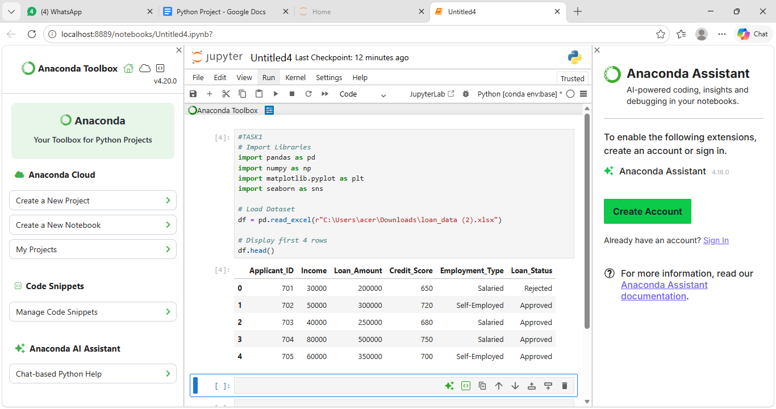
The required libraries were successfully imported for data manipulation and visualization.The dataset was loaded into a pandas DataFrame,and the first few rows were displayed to understand the structure and contents of the dataset.

Task 2: Dataset Overview:
- Display:
  - Shape of the dataset
  - Column names
  - Data types
- Use .info() and .describe() to summarise the data.


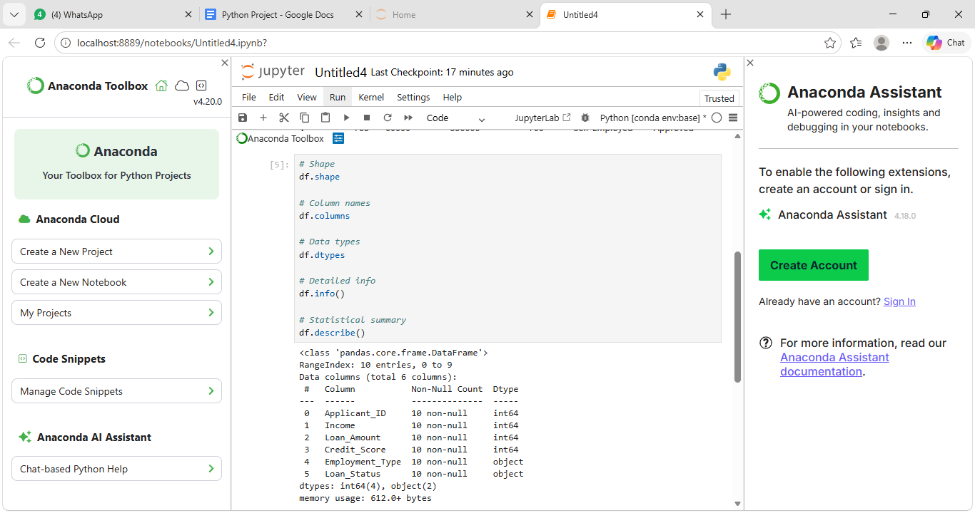
The dataset contains multiple rows and columns representing Loan data information.The .info() output shows both numerical and categorical variables.The .describe() summary provides statistical measures such as mean, minimum, and maximum values for numerical variables, helping us understand the overall data distribution.

Task 3: Data Cleaning (EDA Level):
Perform basic cleaning required for analysis:
- Check for missing values and document them(no missing values)
- Handle duplicates if present(no duplicate)
- Correct incorrect data types(no incorrect data type)
- Standardise column names if necessary

In the data cleaning steps has No missing values , No duplicate values, No incorrect data types.

Task 4: Univariate Analysis:
Analyse individual variables based on their data type:
- Numerical variables(we take Income value)
  - Histograms
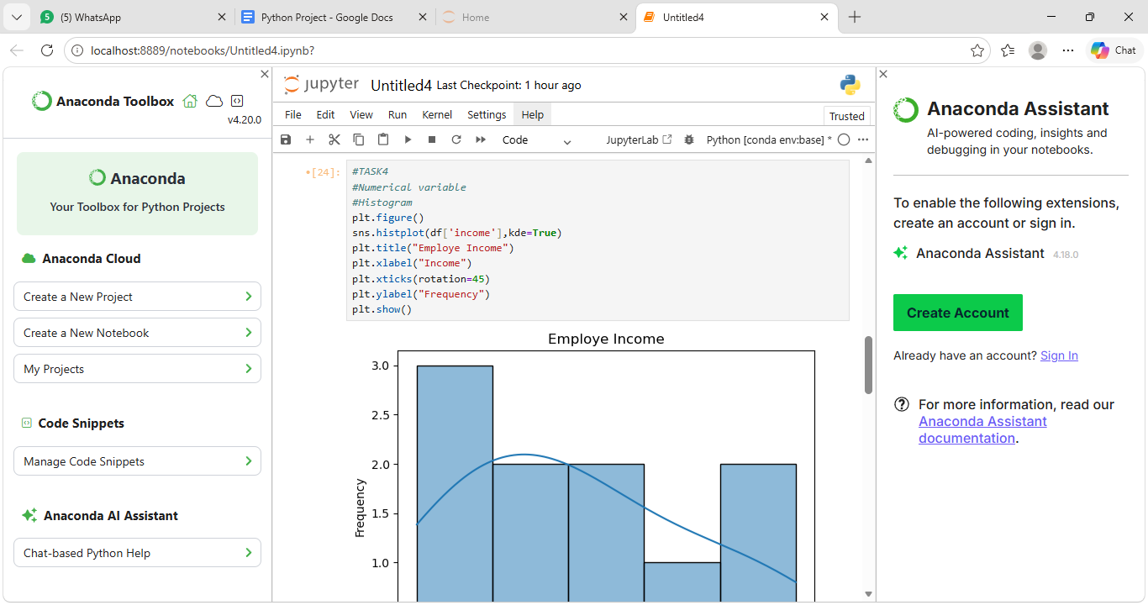
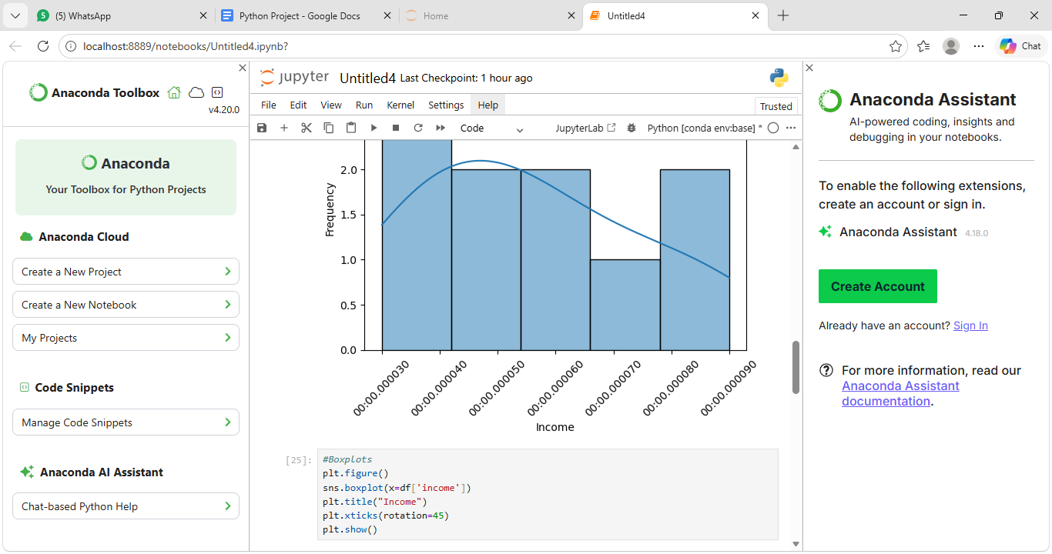
The histogram shows the distribution of Income.Most of Income value fall within a specific range of values.

  - Boxplots

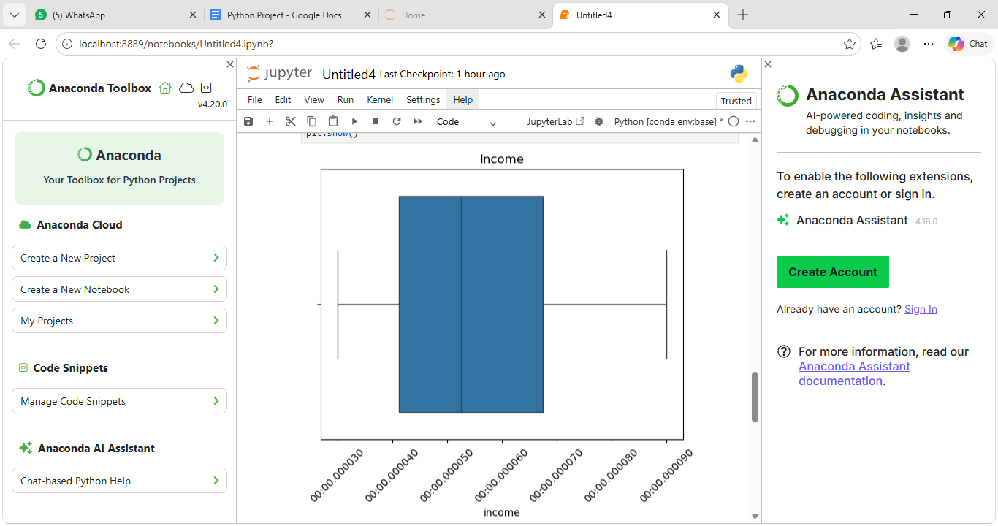
The box plots shows the distribution of income values.

- Categorical variables(we take Loan Status)
  - Value counts
  - Bar plots
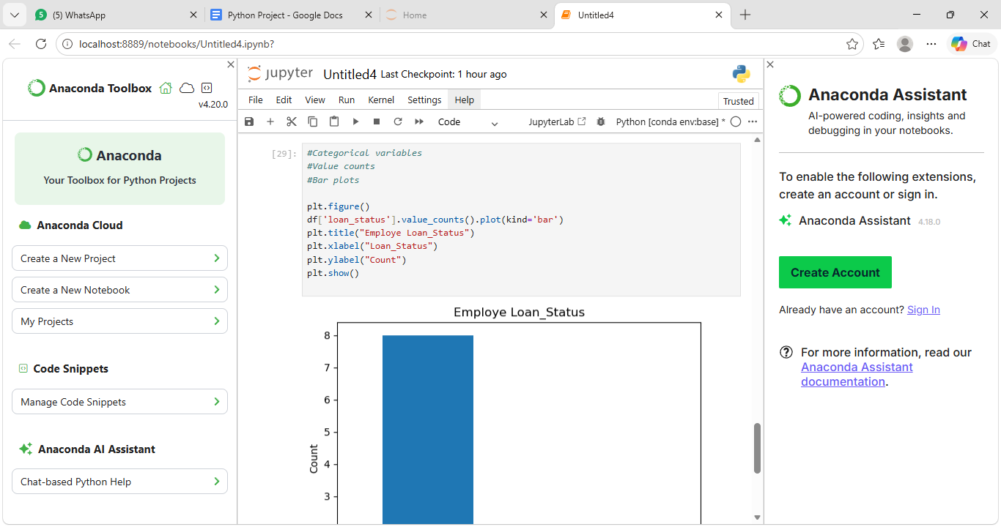
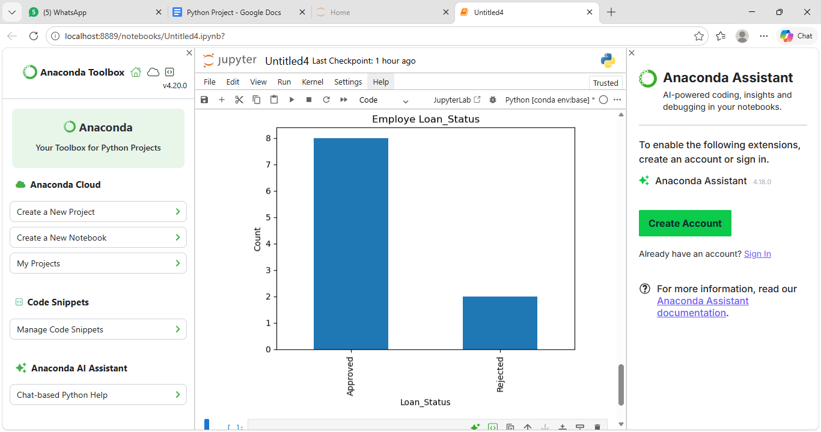
The bar chart shows the distribution of Loan status across different count of Employees.Approved status have significantly higher compared to Rejected status.

Task 5: Bivariate Analysis:
Analyse relationships between variables:
- Numerical vs Numerical
  - Scatter plot(Income vs loan amount)
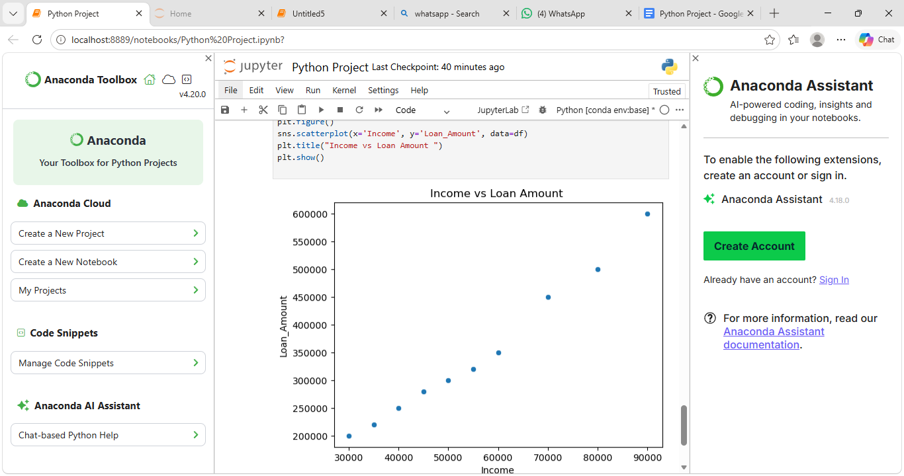
The scatter plot suggests a relationship between Income and Loan Amount.The income values higher based on the Loan Amount.

  - Correlation heatmap
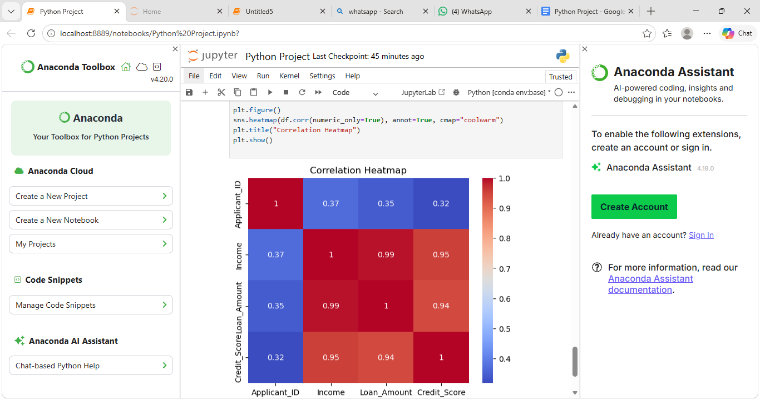The Correlation heatmap highlights correlations between numerical variables. The heatmap shows the values of Application_ID,Income,Loan_Amount,Credit_Score.

- Categorical vs Numerical
  - Boxplot or bar chart(we take boxplot for loan amount by loan status)
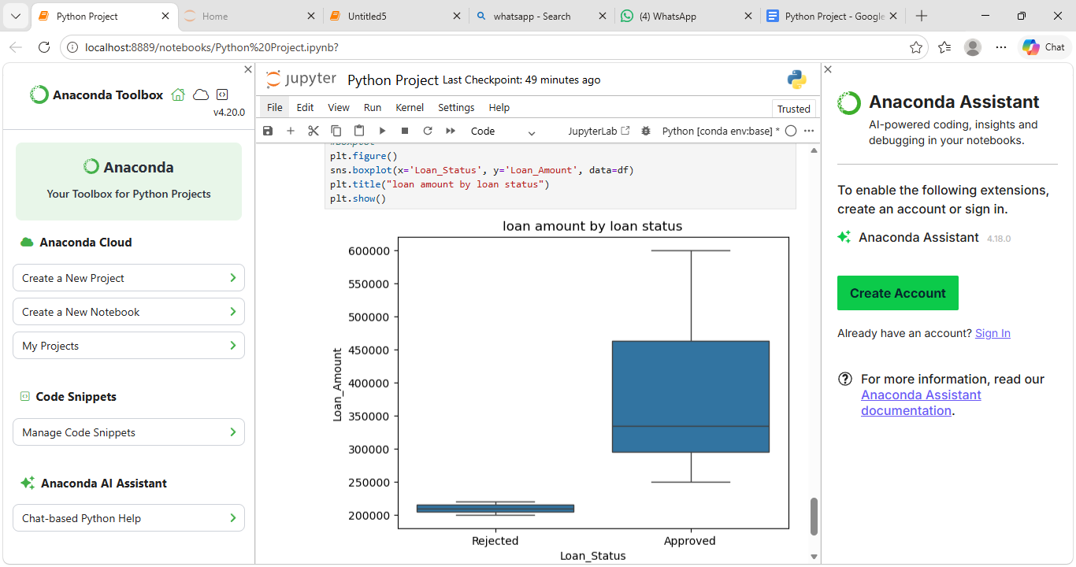
The bivariate has categorical vs numerical of value using charts like bar plots has Loan_Status vs Loan_Amount.

Task 6: Multivariate Analysis:
- Use one of the following (as applicable):
  - Pairplot
  - Facet-based plots
  - Grouped bar charts
- Analyse interaction between more than two variables.
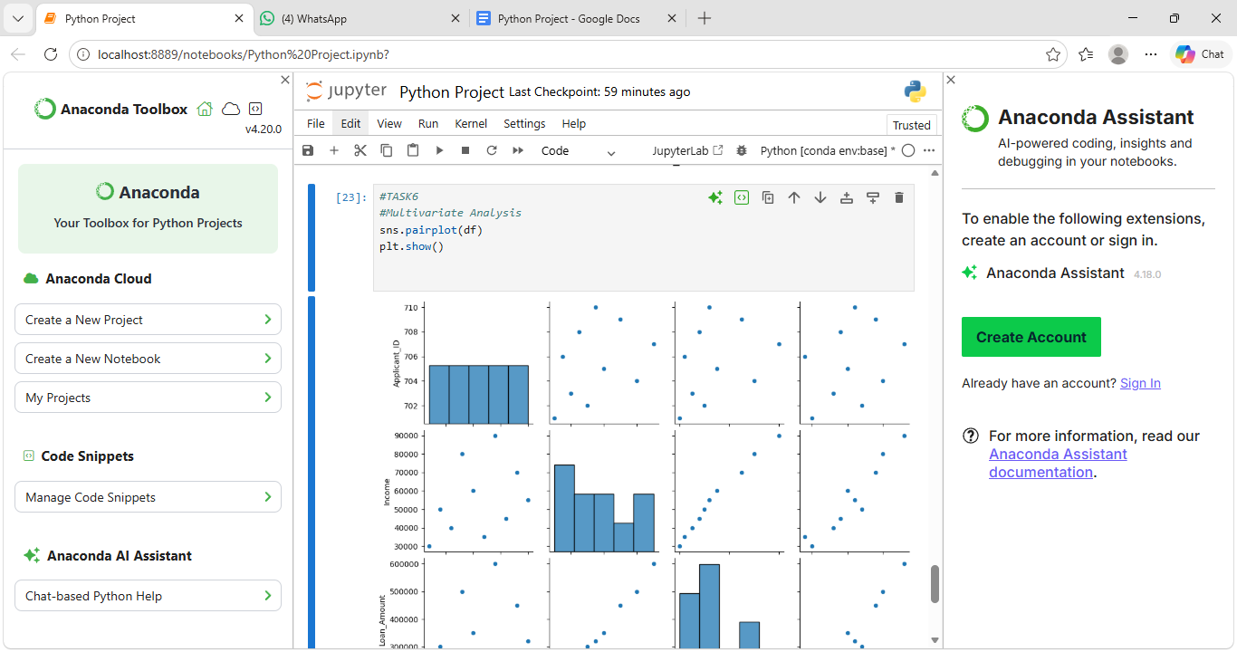
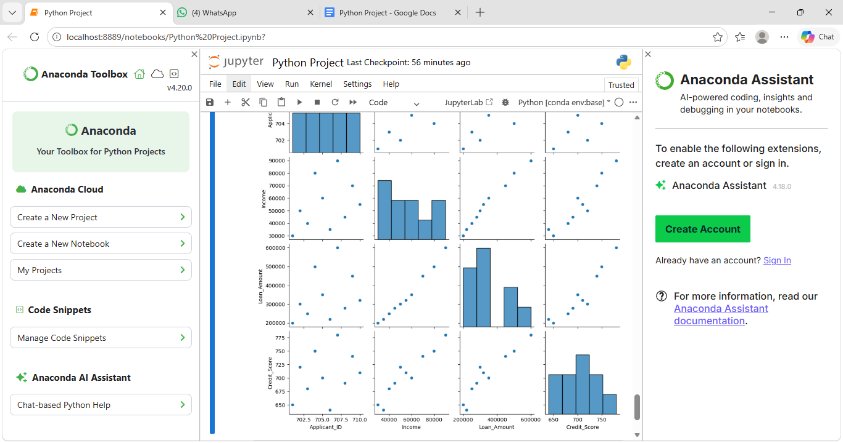

The pairplot provides a combined view of relationships and distributions among selected values.It confirms patterns observed in previous analyses.

Task 7: Data Distribution & Outliers:
- Identify skewness and spread of numerical variables
- Detect outliers using boxplots or IQR method
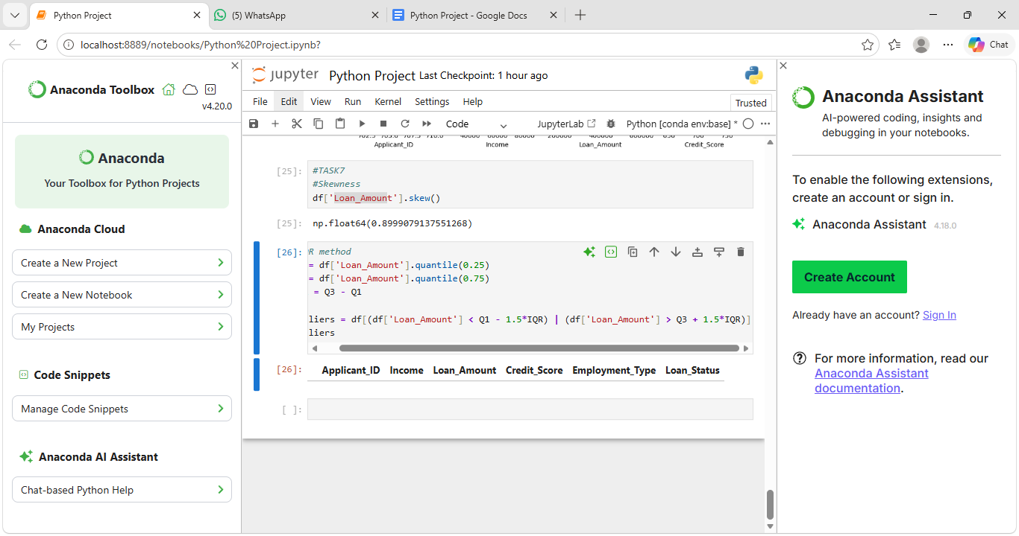
It detects the outliers using IQR methods with a Loan_Amount.

Task 8: Visualization Summary:
Create a final visual summary:
- 3–4 key plots that best describe the dataset
- Ensure plots have:
  - Titles
  - Axis labels
  - Proper scaling
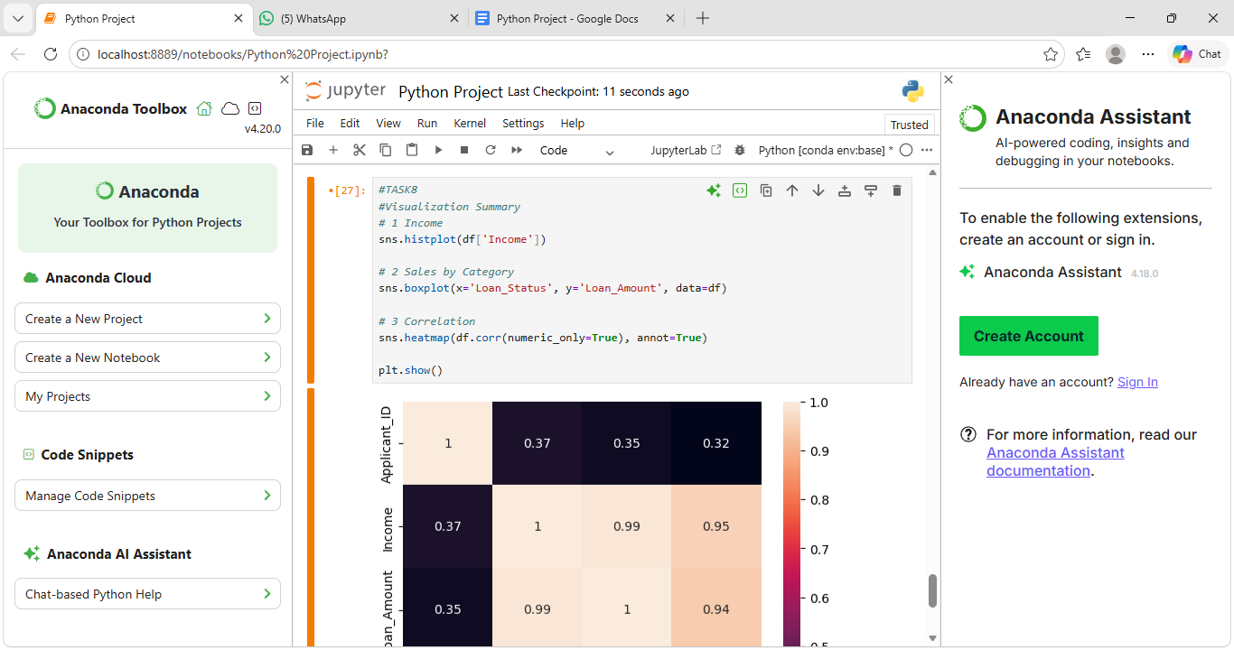
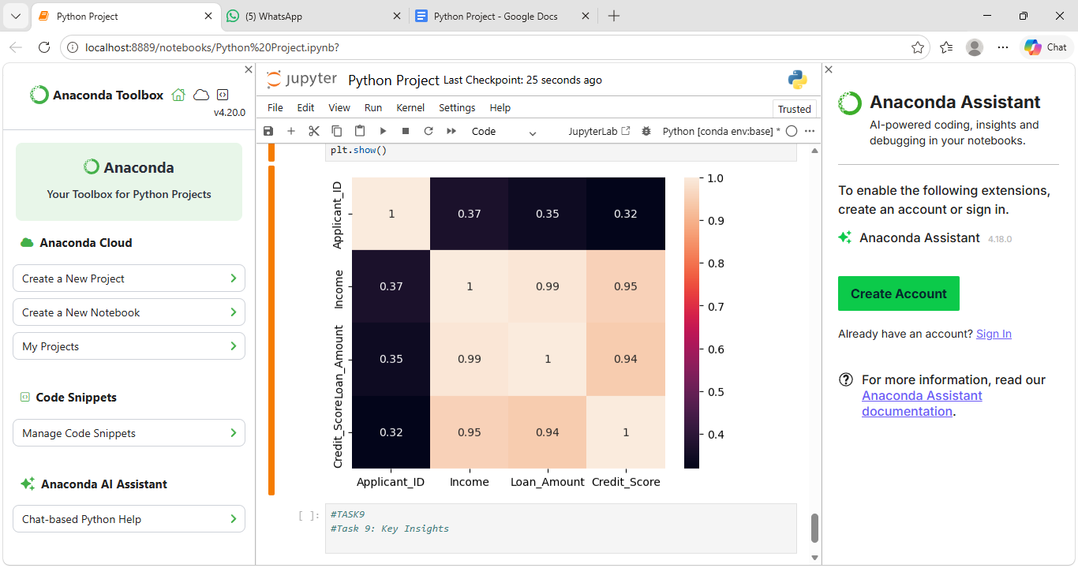
We using the 3 key plots are histogram,heatmap,boxplot.It ensure the plot of Tiles,Axis labels,Proper scaling with describe the best dataset.

Task 9: Key Insights:
1. Income Distribution Pattern:
The employee income values are not evenly distributed. Most employees fall within a middle income range, indicating a concentration of individuals with moderate earnings.
2. Right-Skewed Distribution:
The histogram shows a right-skewed pattern, meaning there are a few employees with very high income compared to the majority.
3. Majority in Lower–Middle Range:
A large number of records appear in the lower to middle income brackets, suggesting that high-income employees are relatively fewer.
4. Presence of Income Variation:
The spread of bars across different ranges indicates variation in employee income levels within the dataset.
5. Potential Impact on Loan Analysis:
Since income is an important factor for loans, the distribution suggests that loan approval patterns may depend heavily on this mid-income group.

